Danielle,

Good afternoon. Here is the report that you requested from me. Please let me know if you have any further questions.

First of all, I have some very good news. I was able to create a model that predicts with a very high level of accuracy of 98% which computer a customer is most likely to purchase. The data provided to me included salary, age, education level, type of car, zip code, and credit limit. I determined that the only important factors for determining brand preference were salary, age, and credit-with salary and age being the predominant top 2 factors.

I selected 2 different classification models to train my data: Random Forest using caret and C5.0. First, I trained on caret using every feature from the data which was provided to me. I chose to use cross-fold validation each time. I slightly tuned my model and I was hitting around 92% accuracy. However, when I ran the model, after feature selection, using only salary, age, and credit then the accuracy increased to 98% on my test set. I had equally high levels of accuracy using C5.0.

Enough with the small details, here is the information you requested.

Brand preference

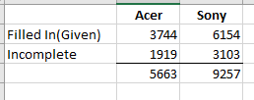 I used my model (shown here with caret RF) to fill in the incomplete data. There are approximately 5663 who will purchase Acer and 9257 who will purchase Sony.

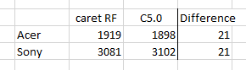 In the above sample I used the predictions from the caret Random Forest. Here you can see that the model predictions only disagreed 21 times in the 5000 points of data.

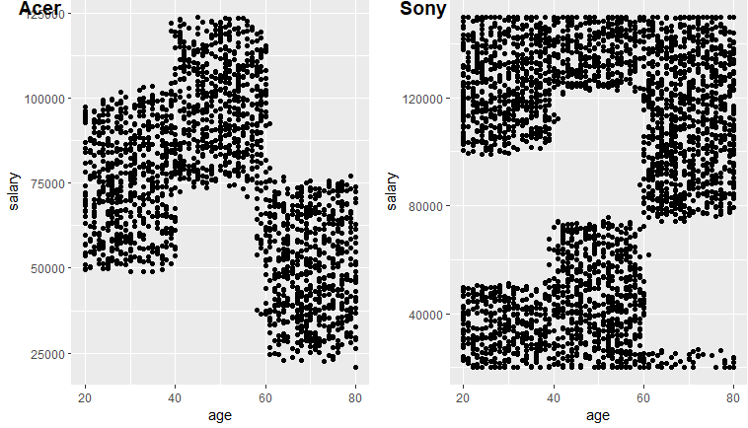

This graph shows which computer a customer will buy based on their age and salary.

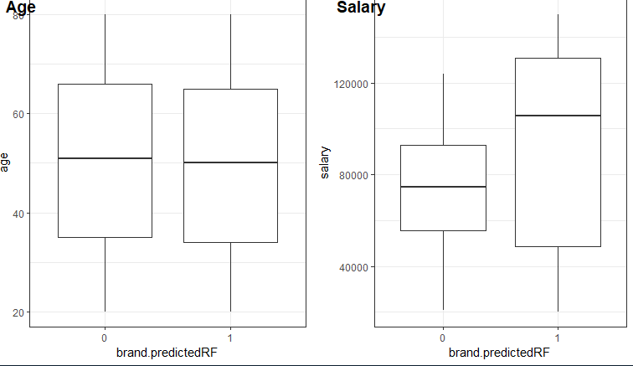

These graphs are the very interesting. There are some patterns to this data.

Customers who prefer Acer can be any age. This customer has on average a lower salary. Age20-40 customers earn between 50k-100k, Age41-60 customers earn between 75k-125k, and customer over 60 typically earn less than 75K.

Customers who prefer Sony can be any age. This customer typically has on average a higher salary. Age 20-40 customers earn under 50k and over 100k, age 41-60 customers earn over 120k and under 75k, and customers over 60 earn over 80k although some of the lowest earners buy this model as well.

For example, a 45-year-old customer who makes 95K will purchase an Acer computer, while a 25-year-old who makes 25K will purchase a Sony.

Please let me know how I can assist you further. I attached the spreadsheet with the predicted brand preferences to assist you in marketing to your customer base. I think you will find this very helpful.

Thank you----Sherri Koski